BG’s Checklist

# Overview

A Business Group Entity consists of certain Properties like BG Name, different Users, custom properties etc. so this workflow is developed to check if all these properties of a particular BG are set or not and if they are, then whether in proper and specified format or not. This workflow list out all the properties related to a Business Group and also tells the flaws among them if any.

# Goal

It is prepared to automate the cross checking and correcting a business group entity which earlier was being done manually.

# Solution /Logic design

Set string += ”Property is not set”

Do nothing

If (Property)

Fetch property of a given Business Group

vCACCAFEHost

Yes

No

# 

Write string and bg details like bgname,custom properties,users,AD Container,Reservations,Entitlements as email content and shoot a mail with workflow “send notification”

end

# Business Group properties

* BG Name - Name of the Business Group
* Custom Properties – Properties like “OC”, ”CRN”, ”bgname” are known as Custom Properties.
* Manager Mail – Mail of the Group Manager
* Support users – Different Support Users of the Group.
* End Users – Different End Users of the Group.
* Administrators – Group managers
* Active Directory Container – Container to which BG belongs
* Machine Prefix – a prefix for the BG with which every machine name starts created under a group.
* Reservations – different Quotas provided to a group
* Entitlements – different authorization for a Business Group.

Dependencies

# Related Actions

* ValidateEmail – It validates the mail Address.
* verifyBGName – it verifies if a Business Group Name is set or not.
* verifyCustomProperties - verifies custom Properties are set or not.
* Verifysupportusers - if support users are set or not.
* verifyEndUsers – if end users are set or not.
* verifyManagerMail – if mail is set or not.
* verifyActiveDirectoryContainer – if AD Container is set or not.it also verifies if the OU name to which the BG belongs to is same as theBG name or not.
* verifyMachinePrefix – if machine prefix is set or not.
* verifyReservations – it firstly verifies if reservations related to a BG exist, if exist then it checks for the format it lies in.
* verifyEntitlements – it firstly verifies if entitlements related to a BG exist, if exist then it checks for the format it lies in. It also verifies how many number of entitlements exist.
* getmachinePrefix - get value of machine prefix.
* listBG – get all the existing Business Groups.

# Related WorkFlows

* Send notification – It attaches two files with the mail and sends it to the requester.

# Related Configuration elements

* fromName – Sender’s name who is sending the mail
* fromAddress – Sender’s email address
* vCACCAFEHost – host through which VRO connect with VRA to fetch the required data.
* SmtpHost – with which one will be able to connect to the server to send the mail.
* CcAddress – it includes other member’s mail address to whom requester wants to send the mail.
* smtpPort - with which one will be able to connect to the server to send the mail.

# Attributes

These are the attributes used in the workflow which are self-explanatory from the picture.

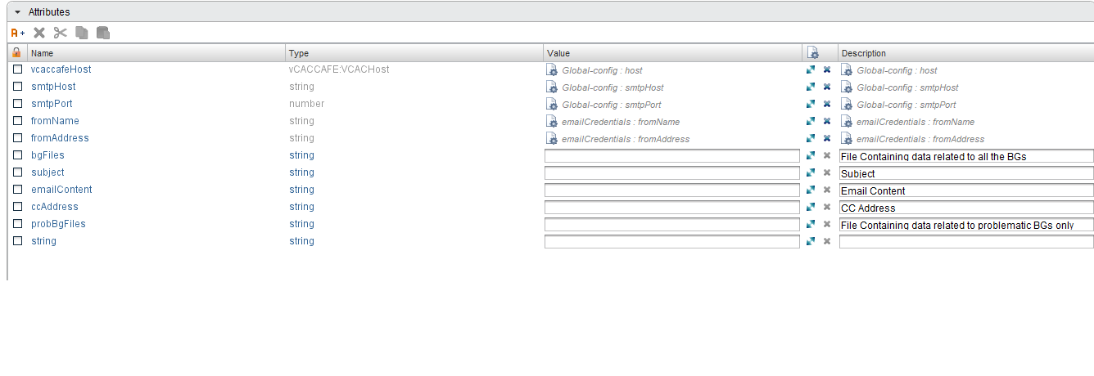

# Inputs

These are the inputs used in the workflow which are self-explanatory from the picture.

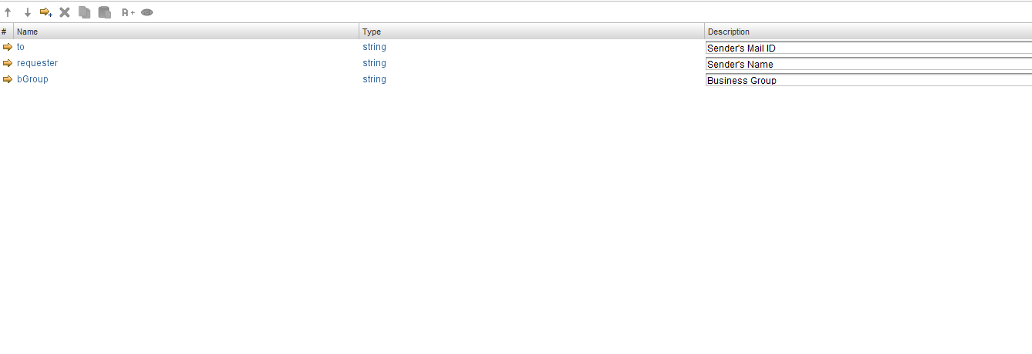

# Future scope

It can further be extended:

* To analyze the quota provided to different reservations of a BG.
* To analyze the authorization of the users comes under a BG and items and services the BG can have access to.